#### 

Medical Practice:

Database Requirements

Red Opal Innovations

Version 1

**Created by:** Viyada Tarapornsin

Table of Contents

Business domain 3

Business requirements 3

Patient management 3

Appointment management 4

Practitioner management 5

Pathology test request management 6

Login management 7

System Context Diagram 7

Functional requirements 8

Version control 11

Sign-off 11

# Business domain

The core business of the Medical Practice is to offer a wide variety of medical services, including general medical services, physiotherapy, podiatry, optometry, blood pressure check, an electrocardiogram of patients’ heart, immunisation, general health screening, pathology test request, etc. The medical services are provided by different types of practitioners, consisting of medical practitioner (doctor or GP), medical radiation practitioner, diagnostic radiographer, radiation therapist, nurse, registered nurse, enrolled nurse, midwife, occupational therapist, optometrist, osteopath, physiotherapist, physical therapist, podiatrist, psychologist.

In order to effectively serve patients to level of their satisfaction, Medical Practice primarily focuses on four business domains, including patient management, appointment management, practitioner management, and pathology test request management.

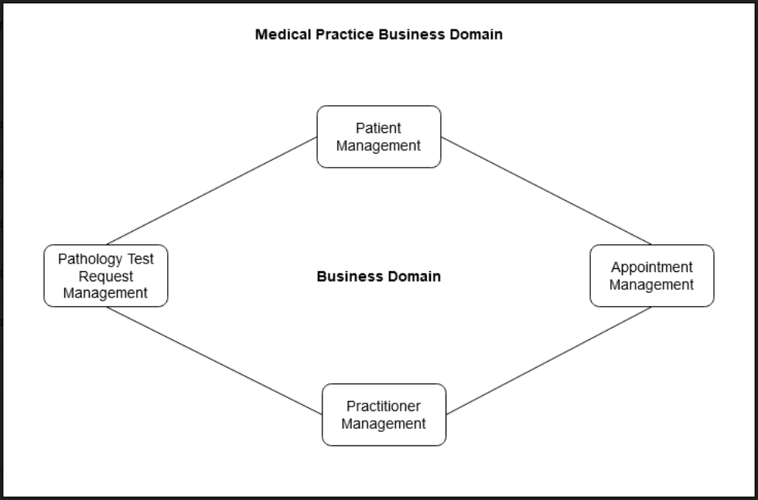

# Business requirements

With the main business focus on the provision of medical services, the business is required to consider the following functional areas, in order to improve the medical services provided to patients in term of processing time, reliability, privacy and confidentiality of patients’ information.

## Patient management

This functional area is to maintain patients’ personal data, like title, first name, middle initial (optional), last name, address including house or unit or lot number, name of street or road, suburb, state, postcode, contact numbers (optional) including home phone and mobile phone, Medicare number (optional), date of birth and gender.

### Rules:

1. There is only one record per patient, which is updateable, in the database.
2. The addresses of patients are in Australia only.
3. Each record must contain a patient’s current personal details, which are categorised into 2 types:
4. Mandatory data

These data must be supplied into the system, including:

* Title
* First name
* Last name
* House, unit or lot number. e.g. 3/45
* Street/road name
* Suburb
* State
* Post Code
* Date of Birth
* Gender

1. Optional data

These data are optional. They can be left out if patients do not have them.

* Middle Initial
* Home phone number
* Mobile phone number
* Medicare number

1. Not all Patients will have a Medicare Number, however, their Medicare number must be unique, if they have one.
2. Patients’ records are never to be deleted from the database.

## Appointment management

This functional area is to keep track of all appointments between patients and practitioners both in the past and future. An appointment record shows the patient’s details, practitioner with whom the appointment is to be held, and the date and start time of the appointment.

### Rules:

1. An appointment can be made with a practitioner who is available on a specific day.
2. Each appointment is allocated in 15 minutes block, which commences on the quarter hour: 00, 15, 30, and 45.
3. A patient can book for more than one 15 minutes block. For example, a patient can book for three 15 minutes block. In this case, 15 minutes of three consecutive appointments are kept in the database.
4. Patients can make an appointment with any of the available practitioners.
5. A patient can have only one appointment on the same date and start time. They cannot have a ‘double-booked’ appointment on the same date and start time.
6. A practitioner can have only one appointment on the same date and start time. They cannot have a ‘double-booked’ appointment on the same date and start time.
7. Appointment records must contain:
8. Patient’s details include:

* Title
* First name
* Last name
* Date of birth

1. Practitioner’s details include:

* Title
* First name
* Last name
* Type of practitioner

1. Appointment’s details include:

* Date of the appointment
* Start time of the appointment

1. Appointments can be made by any Medical Practice receptionists for patients to see practitioners.

## Practitioner management

This functional area is to maintain personal details of practitioners, like title, first name, middle initial (optional), last name, address including house or unit or lot number, name of street of road, suburb, state, postcode, contact numbers (optional) including home phone and mobile phone, Medicare number, Australian Health Practitioner Regulation Agency (AHPRA) Medical Registration Number (MRN) (unique number), date of birth, gender, practitioner type, and availability, in forms of days of the week, such as Monday, Tuesday, Wednesday, Thursday, and Friday.

### Rules:

1. There is only one record per practitioner, which is updateable, in the database.
2. Practitioners’ records are never to be deleted from the database.
3. Each record must contain a practitioner’s current personal details, which are categorised into 2 types:
4. Mandatory data

These data must be supplied into the system, including:

* Title
* First name
* Last name
* House, unit or lot number
* Street/road name
* Suburb
* State
* Post Code
* Australian Health Practitioner Regulation Agency (AHPRA) Medical Registration Number (MRN)
* Date of Birth
* Gender
* Practitioner type
* Days of the week available

1. Optional data

These data are optional. They can be left out if patients do not have them.

* Middle Initial
* Home phone number
* Mobile phone number
* Medicare number

1. All practitioners must have only one unique AHPRA MRN.
2. There are 15 different practitioner types. Practitioners can only practise under one type.
   1. Medical practitioner (Doctor or GP)
   2. Medical radiation practitioner
   3. Diagnostic radiographer
   4. Radiation therapist
   5. Nurse
   6. Registered nurse
   7. Enrolled nurse
   8. Midwife
   9. Occupational therapist
   10. Optometrist
   11. Osteopath
   12. Physiotherapist
   13. Physical therapist
   14. Podiatrist
   15. Psychologist
3. Their availability can be any days on the weekday, which include Monday, Tuesday, Wednesday, Thursday, and Friday.
4. The day available will be the whole day, starting from 8:00 AM to 6:00 PM.
5. Their availability (days available in a week) will be fixed.

## Pathology test request management

This functional area is to keep track of details of pathology test requests.

### Rules:

1. Pathology tests can be request by a practitioner during an appointment or any other time outside the appointment.
2. A practitioner cannot request a pathology test for a patient on the same date and at the same time.
3. The details of each request must contain:
4. The type of pathology test

The pathology test must contain pathology test code, name, and description. It can be but are not limited to:

* **Test code:** HLYSN

**Test name:** ABO

**Description:** Haemolysins (serum)

* **Test code:** CPEP

**Test name:** C Peptide

**Description:** C-Peptide: CPEP

* **Test code:** MOLINT

**Test name:** Deafness

**Description:** Autosomal Recessive, Complete GJB2 Gene Sequencing Analysis Connexin 26: CX26: CXB2: Recessive Autosomal Deafness: Autosomal Deafness: Hereditary Deafness: GJB2: DFNB1: Nonsyndromic Neurosensory Deafness: Neurosensory Deafness Type I: DNA deafness gene abnormality: Connexin 30: CX30

* **Test code:** IMISC

**Test name:** Paraneoplastic

**Description:** Paraneoplastic Pemphigus Antibodies [NOTE: Authorisation required from an Immunopathologist]

* **Test code:** ECH

**Test name:** Echis Time

**Description:** Ecarin time

* **Test code:** ENT

**Test name:** Ear, Nose, Throat, Eye Swab

**Description:** includes gram stain (except throat swab) and bacterial culture. Contact screening for Corynebacterium

* **Test code:** RAST

**Test name:** Radioallergosorbent Test

**Description:** RAST: IgE RAST: Allergen Screen: Radioimmunosorbent Assay of Allergens: Allergen-Specific IgE: Aspergillus RAST, Specific IgE: Ig to specific allergens

1. The date that the pathology test was ordered.
2. The time that the pathology test was ordered.
3. The practitioner that ordered the pathology test.
4. The patient for whom the pathology test was ordered.

## Login management

This functional area is to allow users of the system, including receptionists or practitioners who are currently working at the Medical Practice.

### Rules:

1. The Medical Practice Receptionist can make appointments for patients to see practitioners.
2. The details of users of the system consist of:
   1. Username
   2. Password
   3. User role, either receptionist or practitioner
   4. Status, either active or inactive
3. Practitioners and receptionists can be active or inactive. Their status is set to active, if they are currently working at the Medical Practice, otherwise their status is set to inactive.

# System Context Diagram

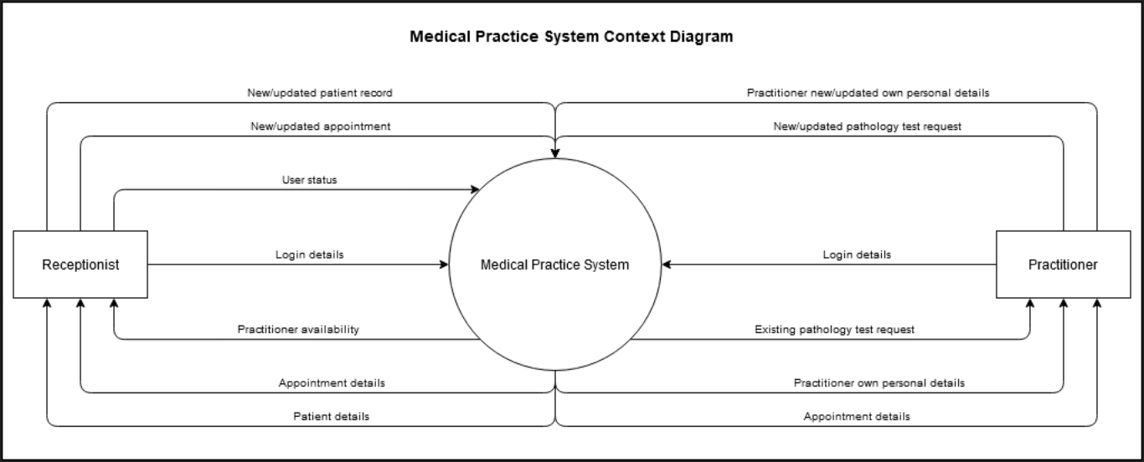The system context diagram shows the logical process that defines the Medical Practice system boundaries. It displays the entities who interact with the system and the data that flows in and out of the system.

# Functional requirements

| **Requirement ID** | **Requirement Statement** | **Must/Want** | **Comments** |
| --- | --- | --- | --- |
| **Patient management functionality** | | | |
| PT001 | A receptionist shall be able to create a new record of a new patient and insert into the database. | Must | INSERT INTO |
| PT002 | A receptionist shall be able to retrieve and view the details of any existing patients. | Must | SELECT *  FROM |
| PT003 | A receptionist shall be able to update the details of any existing patients. | Must | UPDATE TABLE |
| **Appointment management functionality** | | | |
| AP001 | A receptionist shall be able to create new appointments for patients with any available practitioners. | Must | INSERT INTO |
| AP002 | A receptionist shall be able to retrieve and view the details of a patient’s appointments. | Must | SELECT * FROM |
| AP003 | A receptionist shall be able to retrieve and view the details of all the appointments for a practitioner. | Must | SELECT * FROM |
| AP004 | A practitioner shall be able to retrieve and view the details of all his/her appointments on a given date. | Must | SELECT * FROM  WHERE DATE = specific date  AND PractitionerID = specific pratictioner |
| AP005 | A receptionist shall be able to retrieve and view the details of all the appointments for a practitioner on any particular date. | Must | SELECT * FROM  WHERE DATE = specific date  AND PractitionerID = specific pratictioner |
| AP006 | A receptionist shall be able to cancel or delete a future appointment of a patient or a practitioner. | Must | DELETE FROM Appointment  WHERE pratictionerID = specific ID OR patientID = specific ID |
| AP007 | A receptionist shall be able to update an appointment date or time. | Must | UPDATE appointment  SET date = new date,  Time = new time  WHERE patientID = specific ID |
| **Practitioner management functionality** | | | |
| PR001 | A practitioner shall be able to create his/her own new personal record and insert the details into the database. | Must | INSERT INTO |
| PR002 | A practitioner shall be able to retrieve and view his/her personal details. | Must | SELECT * FROM Practitioner  WHERE practitionerID = specific ID |
| PR003 | A practitioner shall be able to update his/her own personal details. | Must | UPDATE Practitioner SET column = value |
| PR003 | A receptionist shall be able to set the statue of any practitioners to be active, if they are currently working at the Medical Practice and to be inactive, if they are currently not working at the Medical Practice. | Must | UPDATE User SET status = false WHERE practitionerID = specific ID |
| **Pathology test request management functionality** | | | |
| PA001 | A practitioner shall be able to create a new pathology test request and insert into the database. | Must | INSERT INTO pathology  TestRequest |
| PA002 | A practitioner shall be able to delete any existing pathology test request. | Must | DELETE FROM pathology TestRequest  WHERE pratictionerID = specific ID AND dateOrdered = specific date  AND timeOrdered = specific time |
| PA003 | A practitioner shall be able to list all pathology test requested for a particular patient. | Must | SELECT * FROM pathology TestRequest  WHERE patientID = specific ID |
| PA004 | A practitioner shall be able to list all pathology test requested by a particular practitioner. | Must | SELECT * FROM pathology TestRequest  WHERE practitionerID = specific ID |
| PA005 | A practitioner shall be able to list all pathology test requests. | Must | SELECT * FROM pathology TestRequest |
| **Login** | | | |
| LO001 | The system should allow the users of the system, including receptionists and practitioners, who are active in the system login to the system using their username and password. | Must | SELECT * FROM User WHERE username = given username AND password = given password AND status = true |
| LO002 | The users should be able to change their password. | Want | UPDATE User  SET password = new password  WHERE username = given username |

# Version control

|  |  |  |  |
| --- | --- | --- | --- |
| No | Effective | Approved by | Updates |
|  |  |  |  |

# Sign-off

|  |  |  |  |
| --- | --- | --- | --- |
| Name | Position/role | Date | Signature |
|  |  |  |  |